QUESTION 1

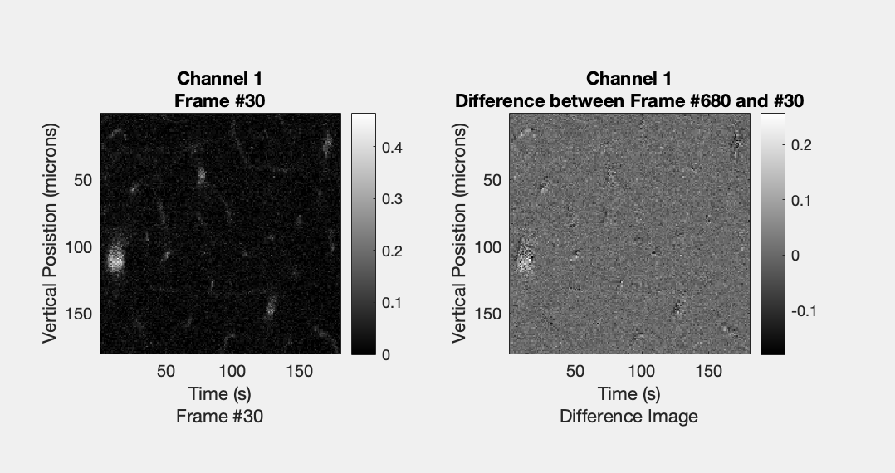

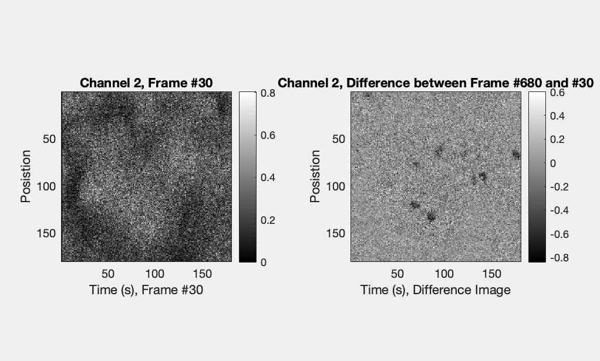

Figure 1. The four images above show blood vessels (dark black spots) and some neurons in mouse cortex following fluorescent tissue staining. Channel 1 (top row) shows around 5 neurons which are defined and active (white stained structures). There are roughly two clusters of neurons. We can see motion indicated in these images due to the neuron activation being different following motion correction (on the right).

‘

QUESTION 2

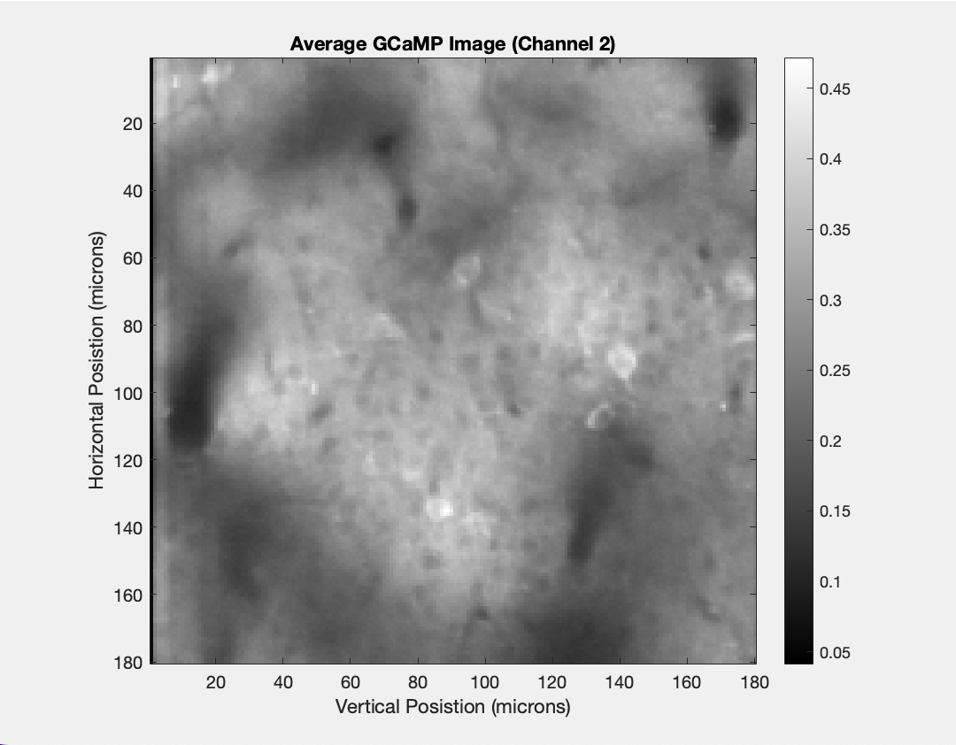

Figure 2. Figure 2 shows the cells in mouse cortex imaged after green GCaMP staining has been completed in the cell tissue. The average over the time period was taken in Channel two to better visualize cell tissue. The black spots correspond to blood vessel while the white correspond to areas of cell activation, or green fluorescence.

QUESTION 3

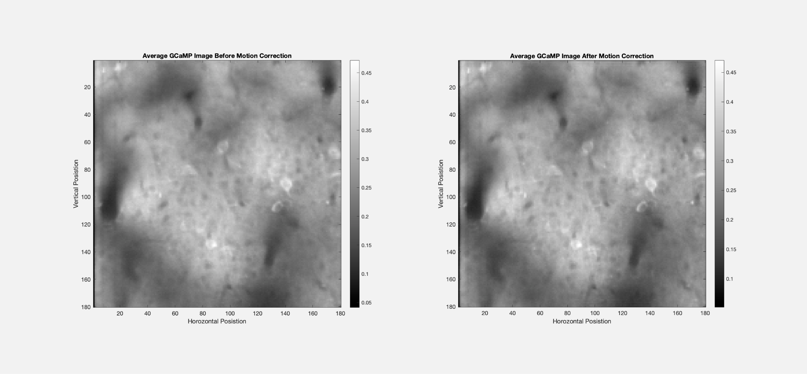

Figure 3. Figure 3 reflects analysis of optical imaging dataset collected from of two-photon imaging data, capturing a time series of 1200 images acquired at 5 frames per second in a single location, in mouse cortex. GCaMP fluorescence was applied to the neuronal tissue to be able to visualize activity from neuron populations within the mouse cortex. GCaMP staining shows differences or similarities in neuronal activity within the imaged locations. The left image shows the average of Channel 2 over the period of time and the right image reflects a motion corrected image of the stained area. It appears there is more contrast between light and dark ares in the motion corrected image (right).Thus the blood vessels (black) and activated cells (white) can be seen more clearly on the right in distinct groups.

QUESTION 3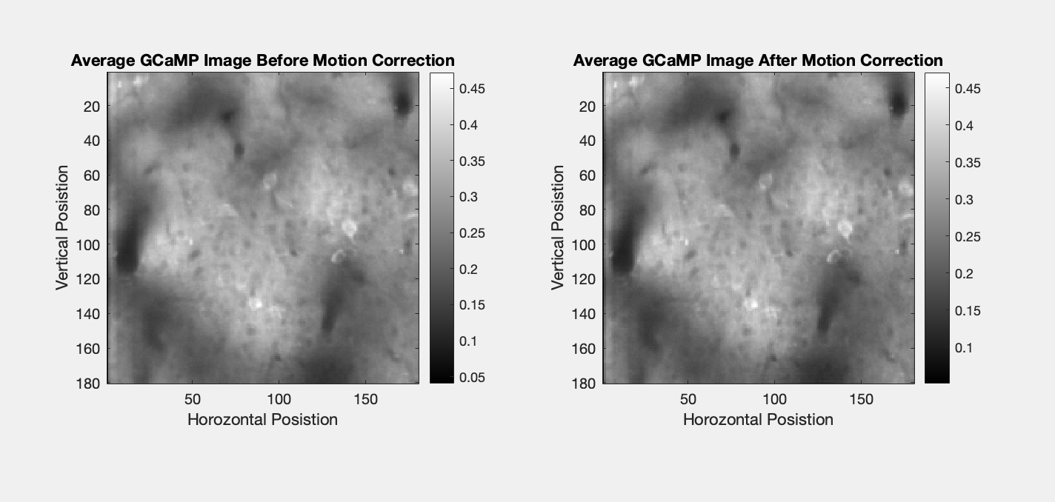

Figure 4. Figure 4 shows stained mouse cortex tissue before motion correction (left) and after (right). We can see that the image are very similar. It seems that the neuron activity is the same (white) in both frames. 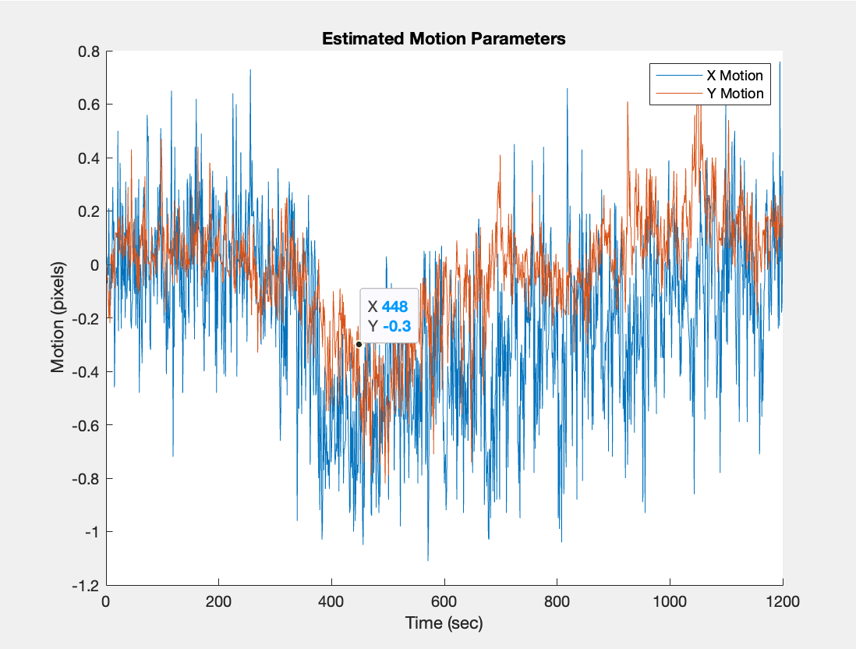

Figure 5. Figure 5 shows motion in the X and Y direction, reflecting activity patterns of cells in mouse cortex. We can see times where there is the most motion and activity, corresponding to neural firing and activity.

SEE CODE FOR MOVIE

STEP 4

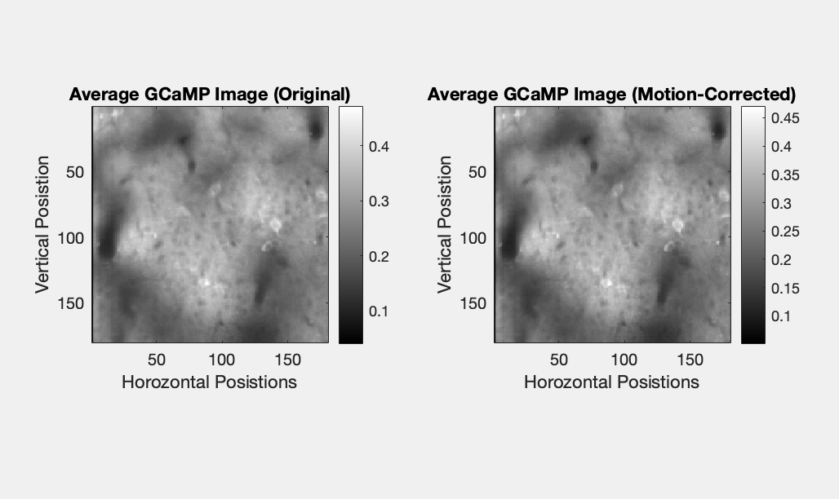

Figure 6. Figure 6 shows motion corrected (right) and an origional image after GCaMP florescence staining in mouse cortex.

QUESTION 5

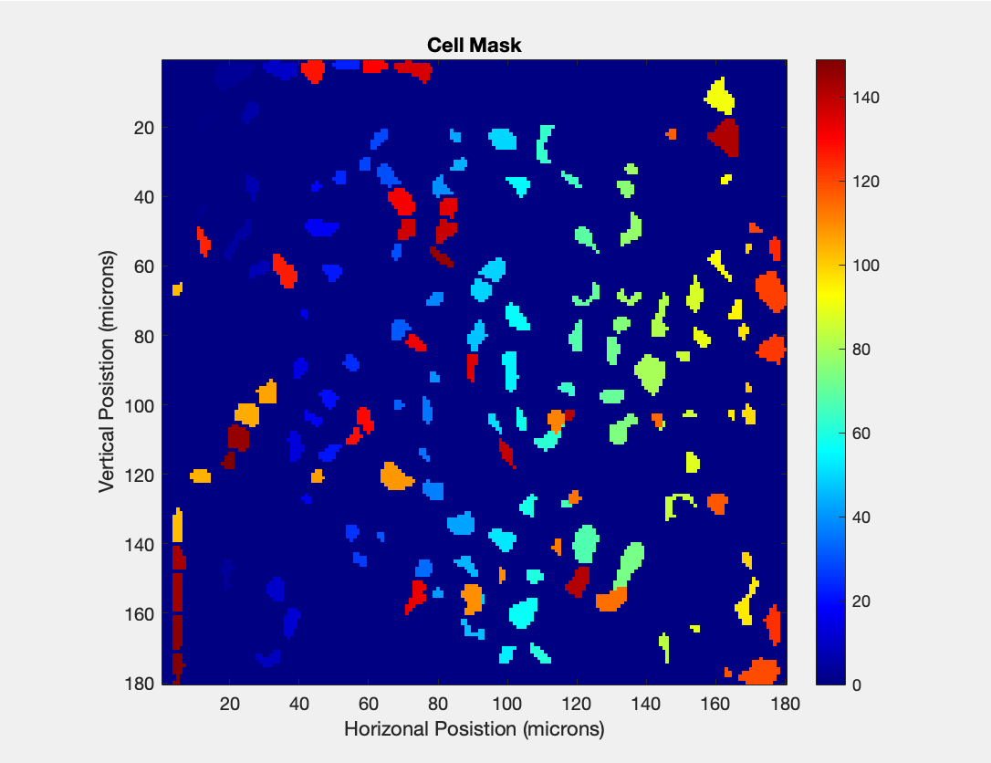

Figure 7. The cell mask above highlights correlation in cells in the image above. You can see that cells with more intensity are more correlated with one another and you can determine where there is the most clustering of cells in the tissue above. The most cultering is towards the center of the image.

QUESTION 6

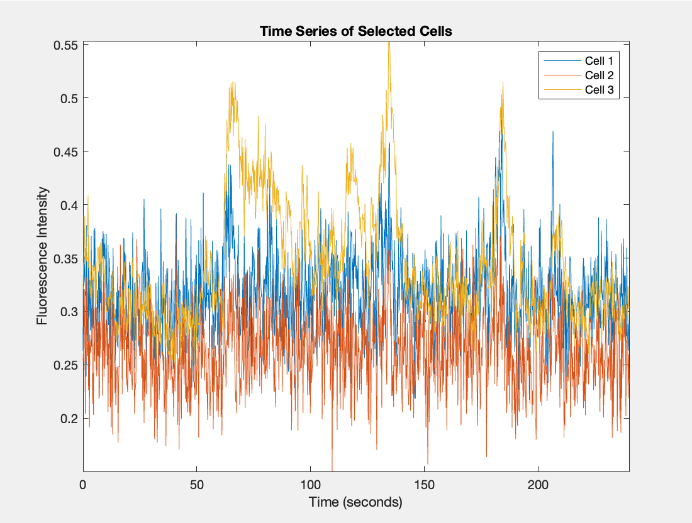

Figure 8. The time series of the selected cells shows that there is a spike in activity around 60 seconds, 130 seconds, and 170 seconds. At these times, cell three is activated. There are similar, smaller spikes in activity in cells one and two, though not to the same degree.

QUESTION 6

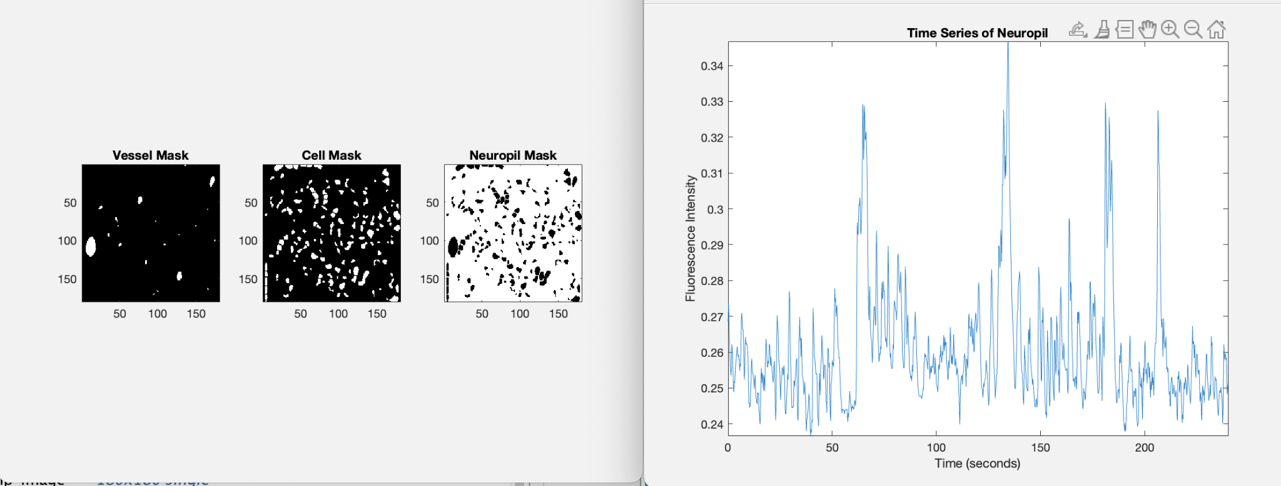

(please ignore the image on the right my computer keeps freezing and won’t let me crop this image)

Figure 9. Figure 9 shows time series for the neutrophil cells. The spikes in activity are similar to those found in the motion corrected GCaMP cells. Three large spikes in activity are detected around 60 seconds, 130 seconds, and 170 seconds.

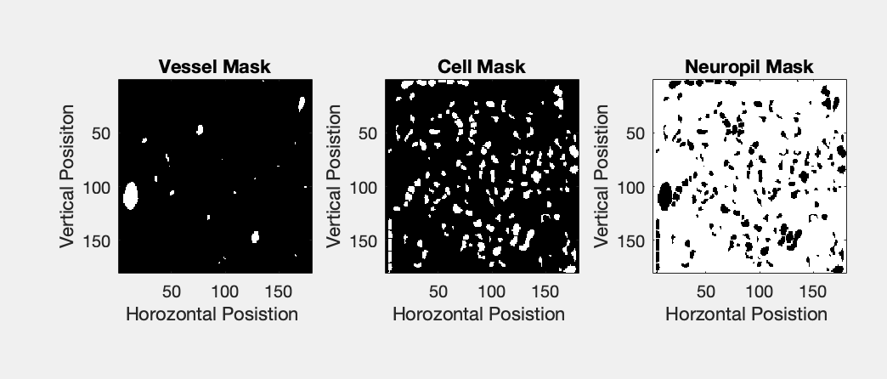

Figure 10. The cell masks above show where vessels, neutrophils, and neurons are located in cell tissue collected from mouse cortex. The vessels are white (left), cells are white (middle), and neutrophils are black (right).

STEP 7

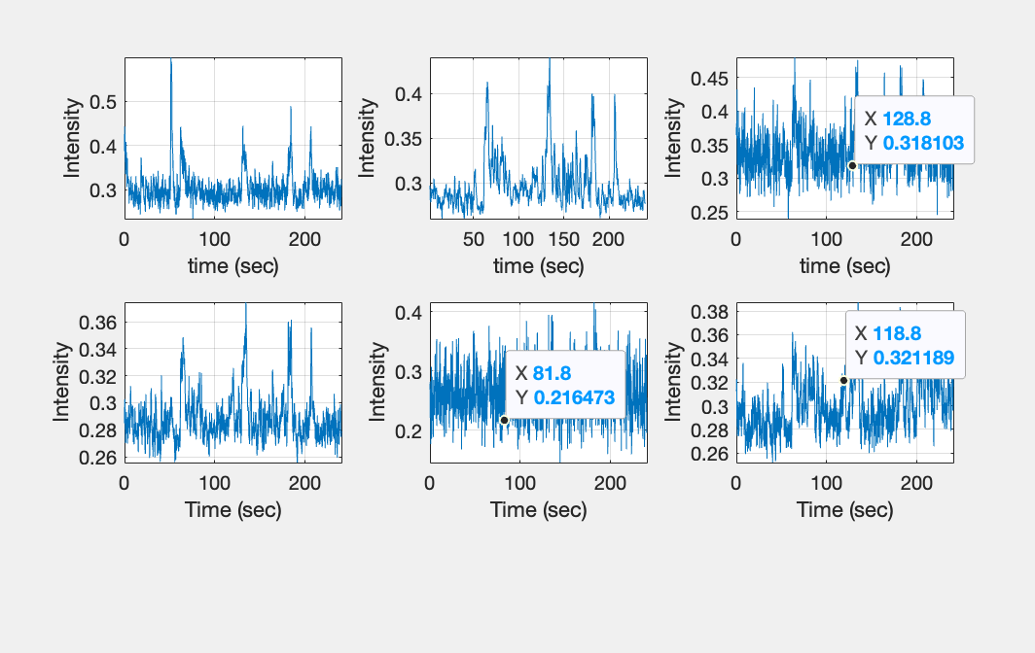

Figure 11. Figure 11 demonstrates time series for each cluster used in K means. It appears as if certain clusters respond with more intensity at certain times, reflecting neuron activity at places where spiking has occurred.

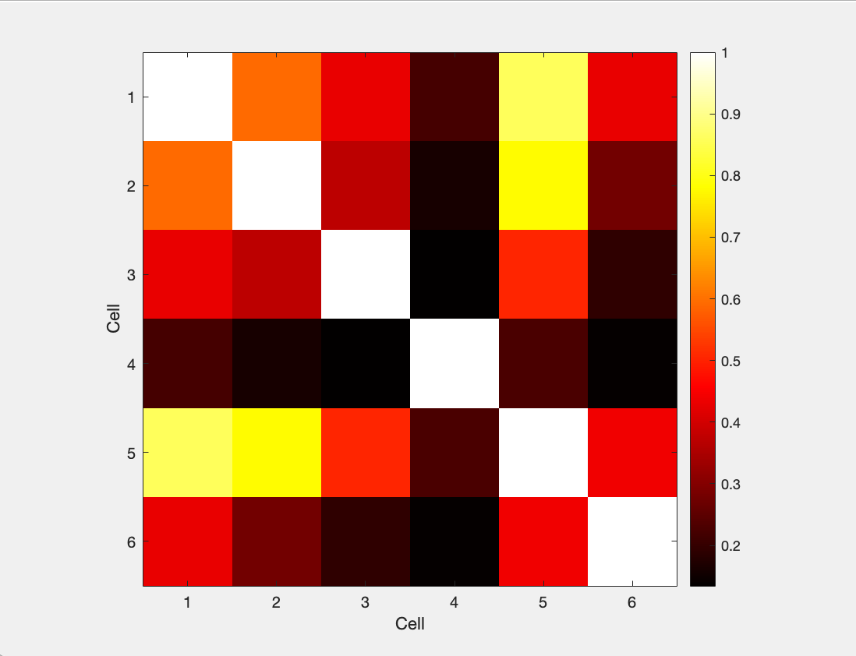

Figure 12. Figure 12 shows the correlation between clustes of cells. White demonstrates high correlation (>.9) and black demonstrates less correlation. Each cell is highy correlated with itself.

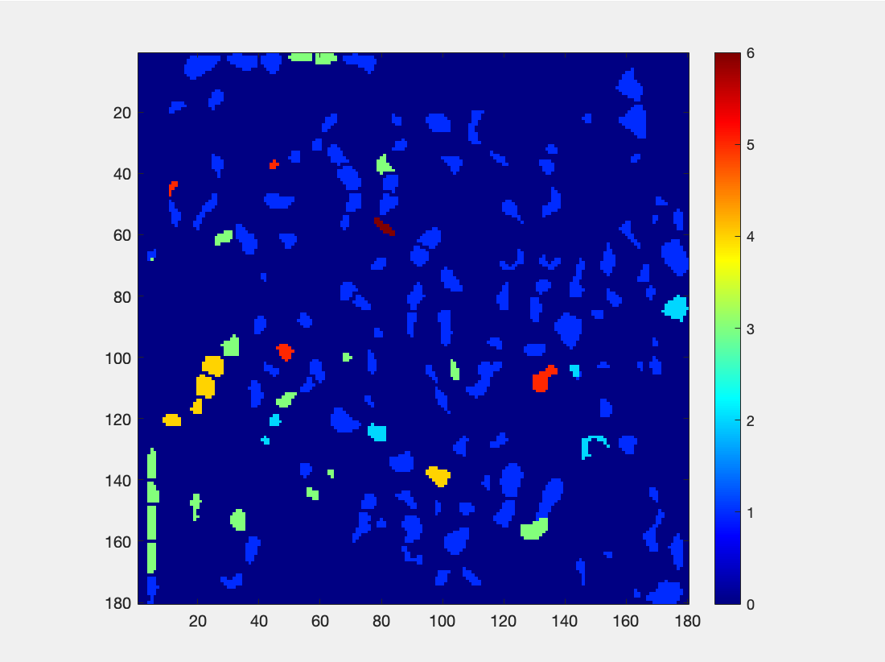

The neutrophil cell mask shows the cells and the intensity indicated by colors. Various groups of neurons can be identified, as well as the correlation with which they are firing, gleamed by the signal intensity and coded by color. For example, there are several green neurons (3).

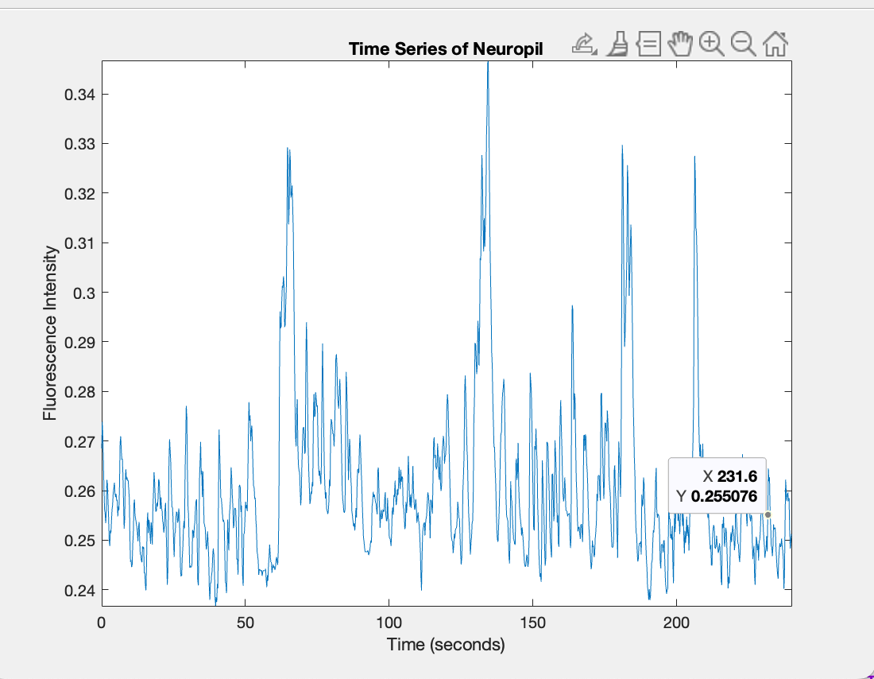

STEP 8: Each cluster is highly correlated with itself in the k-means analysis which means the clustering was well-defined and these are consistent groups. The purpose of doing motion correction during image analysis was to line up the images and reduce the noise and effects o image clarity from motion artifacts. It can help to separating the neural activity and signal from motion-induced artifacts to help identity appropriate numbers of clusters. When selected, this reveled a high correlation justifying the number of cluster (6) selected. I chose this because during the motion corrected movie with frames, it also seemed as though there were around 6 neurons firing.

STEP 9:

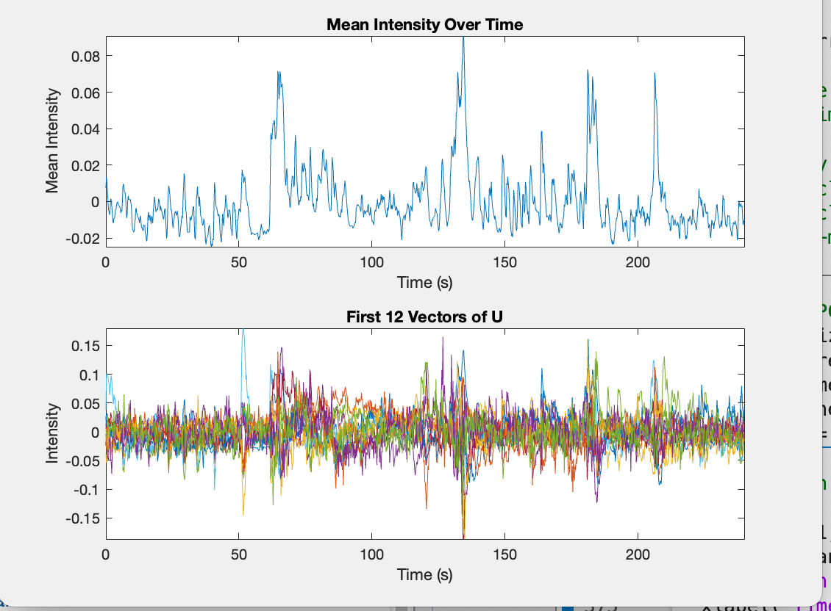

My matlab has been crashing for several days. I promise I generated the correct figure but I just couldn’t print and display it :(

STEP 11/12:

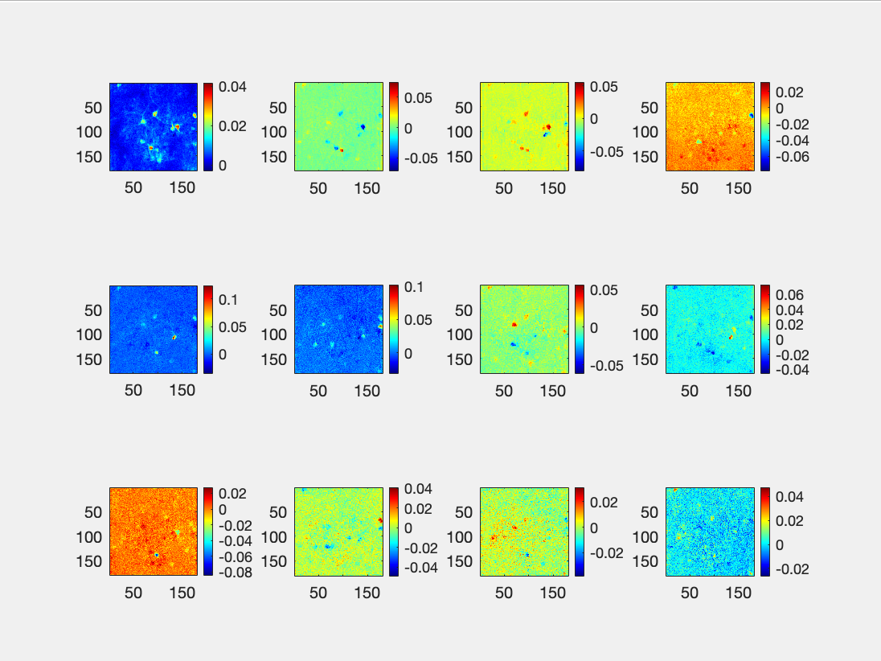

Figure for 11. Figure 11.1 shows coefficient images that correspond to the first 12 components. From top left to right, we see components 1-4. Row 2 shows components 5-8. Row 3 shows components 9-12. Based off color analysis of corelation, there appears to be 4-5 clusters.

STEP 13:

Clusters from k-means give information about neuronal activity and the firing patterns of clusters or groups of neurons. The clusters are different subpopulations of neurons with similar time and space which lets us understand how areas in the brian or how populations of neurons are connected to one another.

STEP 14/15 (15 in caption!)

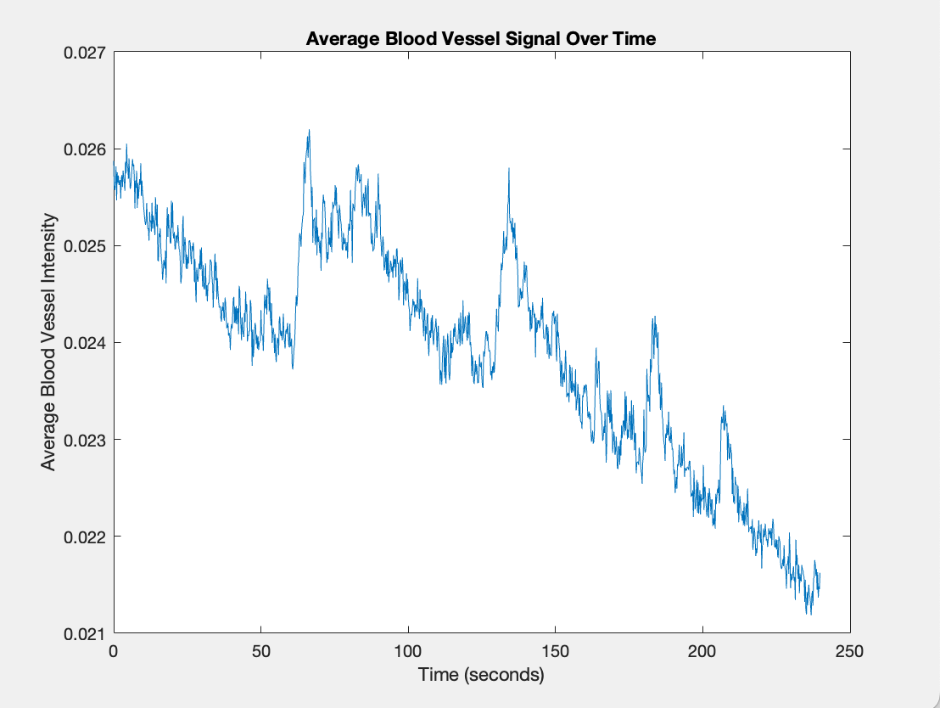

figure for question 15. This figure shoes the average intensity of blood vessel signal over time. Over time, the signal gradually decrease. There are spikes arond 60 seconds, 130 seconds, and 170 seconds. This aligns with the spilkes seen in other intensity analysis over time including with the signal from Channel 2 which was GCaMP stained. This suggests there may be noise or an external factor influencing intensity at these time points. This is similar to the time series calculatedfrom Ch#2 images, matching the expectation that tehre is some sort of noise affecting signal intensity reading at that time.

STEP 15:

Correlation Coefficient: 12404